**HC Coding Assessment API**

**The API formats can be viewed by clicking on the “API” menu item**

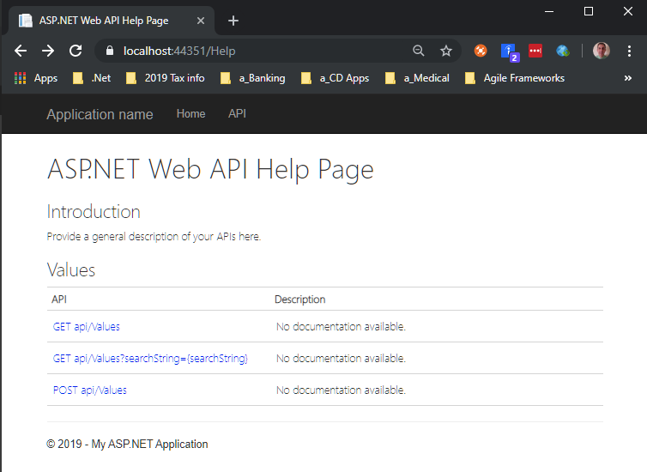

**Get api/values example using Postman:**

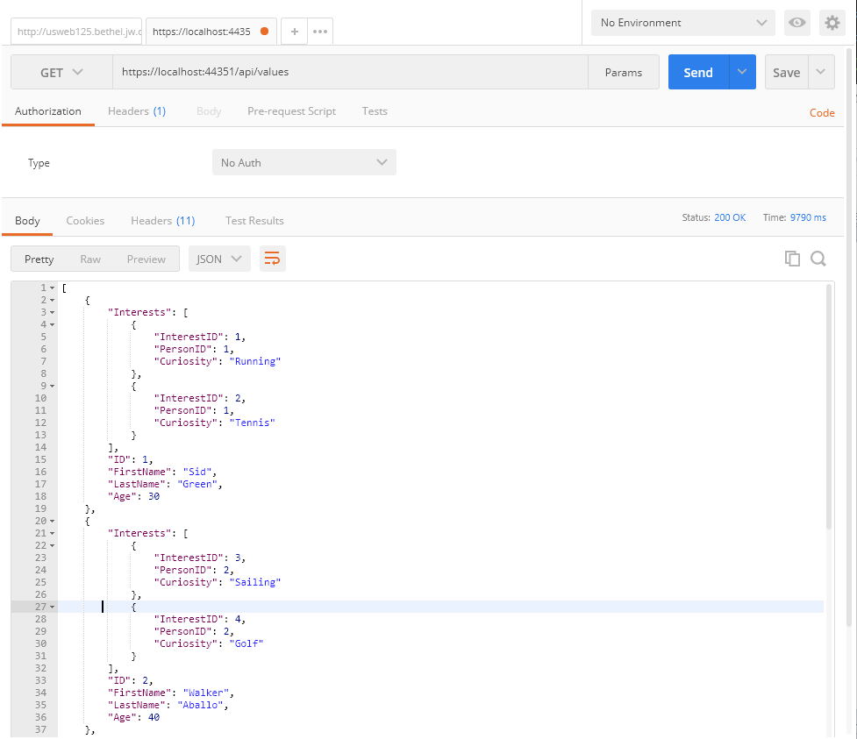

**( The returned JSON is based on the current seeded database entries )**

**GET api/Values?searchString={searchString}**

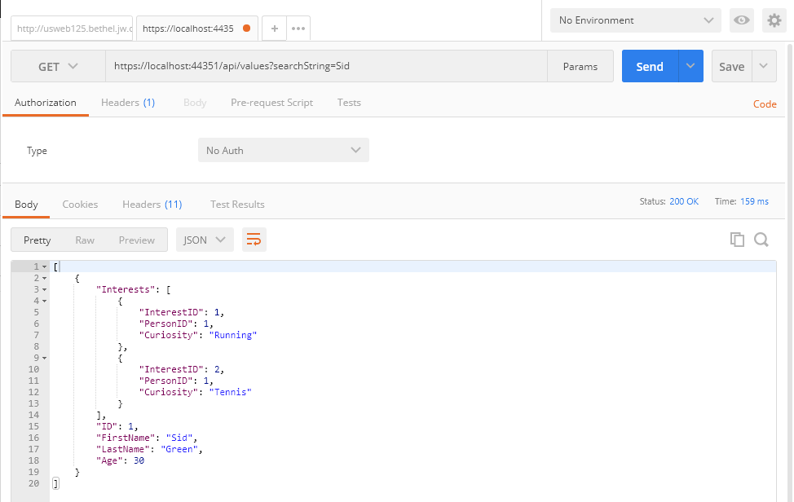

**( The returned JSON contains just the person whose first name or last name matches the search string )**

**POST api/Values/Person**

**Settings before click Send:**

1. Set action to POST
2. Enter in the POST REST API string
3. Set to Body
4. Set to Raw and JSON (application/json)
5. Enter some JSON containing the Person you want to add.
6. Click Send

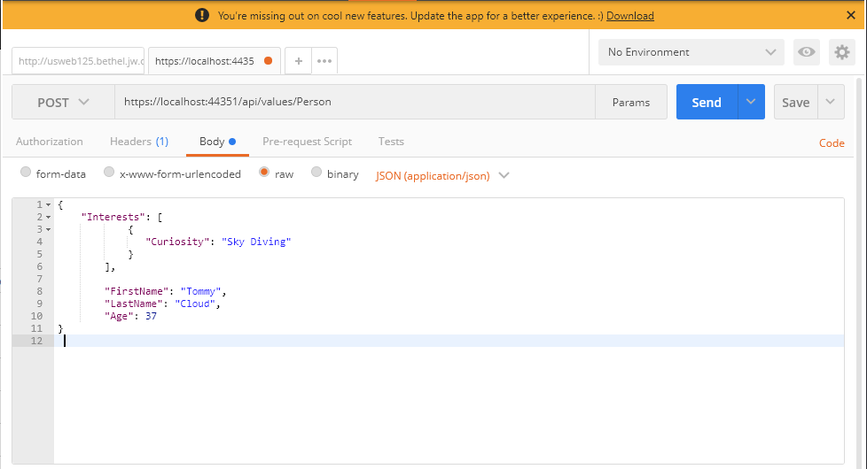

**To Test the previous POST:**

**Run: GET api/Values?searchString={searchString}**

